Public Survey on Transportation
The purpose of this Survey of Transportation Services is to update information contained in the Cattaraugus County Coordinated Transportation Plan.
Your participation will enable us to better evaluate how we can improve the coordination of existing transportation services. If you have questions about the survey, please call Patrick McGlew at 716-938-2387.

What is the name of the village, town or city that you live in?

How old are you? (Please circle an age range)
15-24 | 45-54 | 75-84
25-34 | 55-64 | 85 or older
35-44 | 65-74

Did you use any of the following transportation this year? (Circle on all you used)
 | 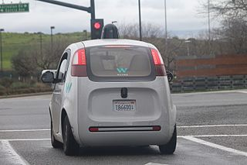
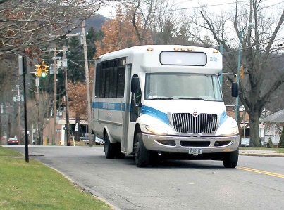 | 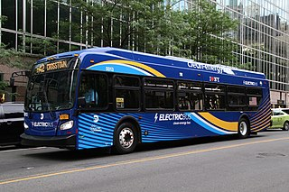

Do you know where to find public transportation schedules?
Yes | No

Are public transportation schedules easy to read and understand?
Yes | No

What cities or towns do you travel to for the following?
Medical/Health Care
Social Services
Employment
Shopping
Recreation / Social
Other

Are you or a family member currently using any transportation services that are available to you through the Medicaid program?
Yes | No

Would you be willing to pay a fair price for the expansion of public transportation services?
Yes | No

If changes could be made to your local transportation systems to make using them easier or more appealing to you, what would they be?

Return the Survey
After you’ve completed this survey please, send this via either:
Mail: Cattaraugus County Dept. of EDPT, c/o Patrick McGlew, 303 Court St., Little Valley, NY 14755
Email: PJMcGlew@CattCo.org | Fax: 716-938-2779

